
Beechen Hall, Wildfell Close, Walderslade, Chatham, Kent ME5 9RU.
01634 861237
clerk@boxleyparishcouncil.org.uk
Clerk: Daniela Baylis
Assistant Clerk Hall: Jane Denham
Assistant Clerk Finance: Lissi Watts
www.boxleyparishcouncil.org.uk

Environment Committee Supplementary Agenda 8 April 2024

19. Lidsing Garden Development

Good Afternoon,

The Inspector’s Final Report on the Examination of the Maidstone Local Plan was delivered to the Council last month, which signifies the formal closure of the Examination.

Follwing the closure of the Examiantion, the Planning Inspectorate have asked me to contact all those who submitted comments in writing, and/or who took part in the hearing sessions, as they would very much appreciate receiving any feedback on the examination that you are able to provide. Any comments that you make will be confidentail and can be made using the short survey which can be accessed via the link below:-

https://forms.office.com/r/vcT3RaRvtY

All feedback is very welcome, as this will assist PINS in being aware of any issues that may have arisen during the examination which can then be addressed for any future examination.

As the Programme Officer for the Examination I would also like to take this opportuity to thank you all for the courtesy you have all shown to me throughout this Examination, and to wish you all the best for the future.

Kind regards,

Louise

Louise St John Howe
Programme Officer,
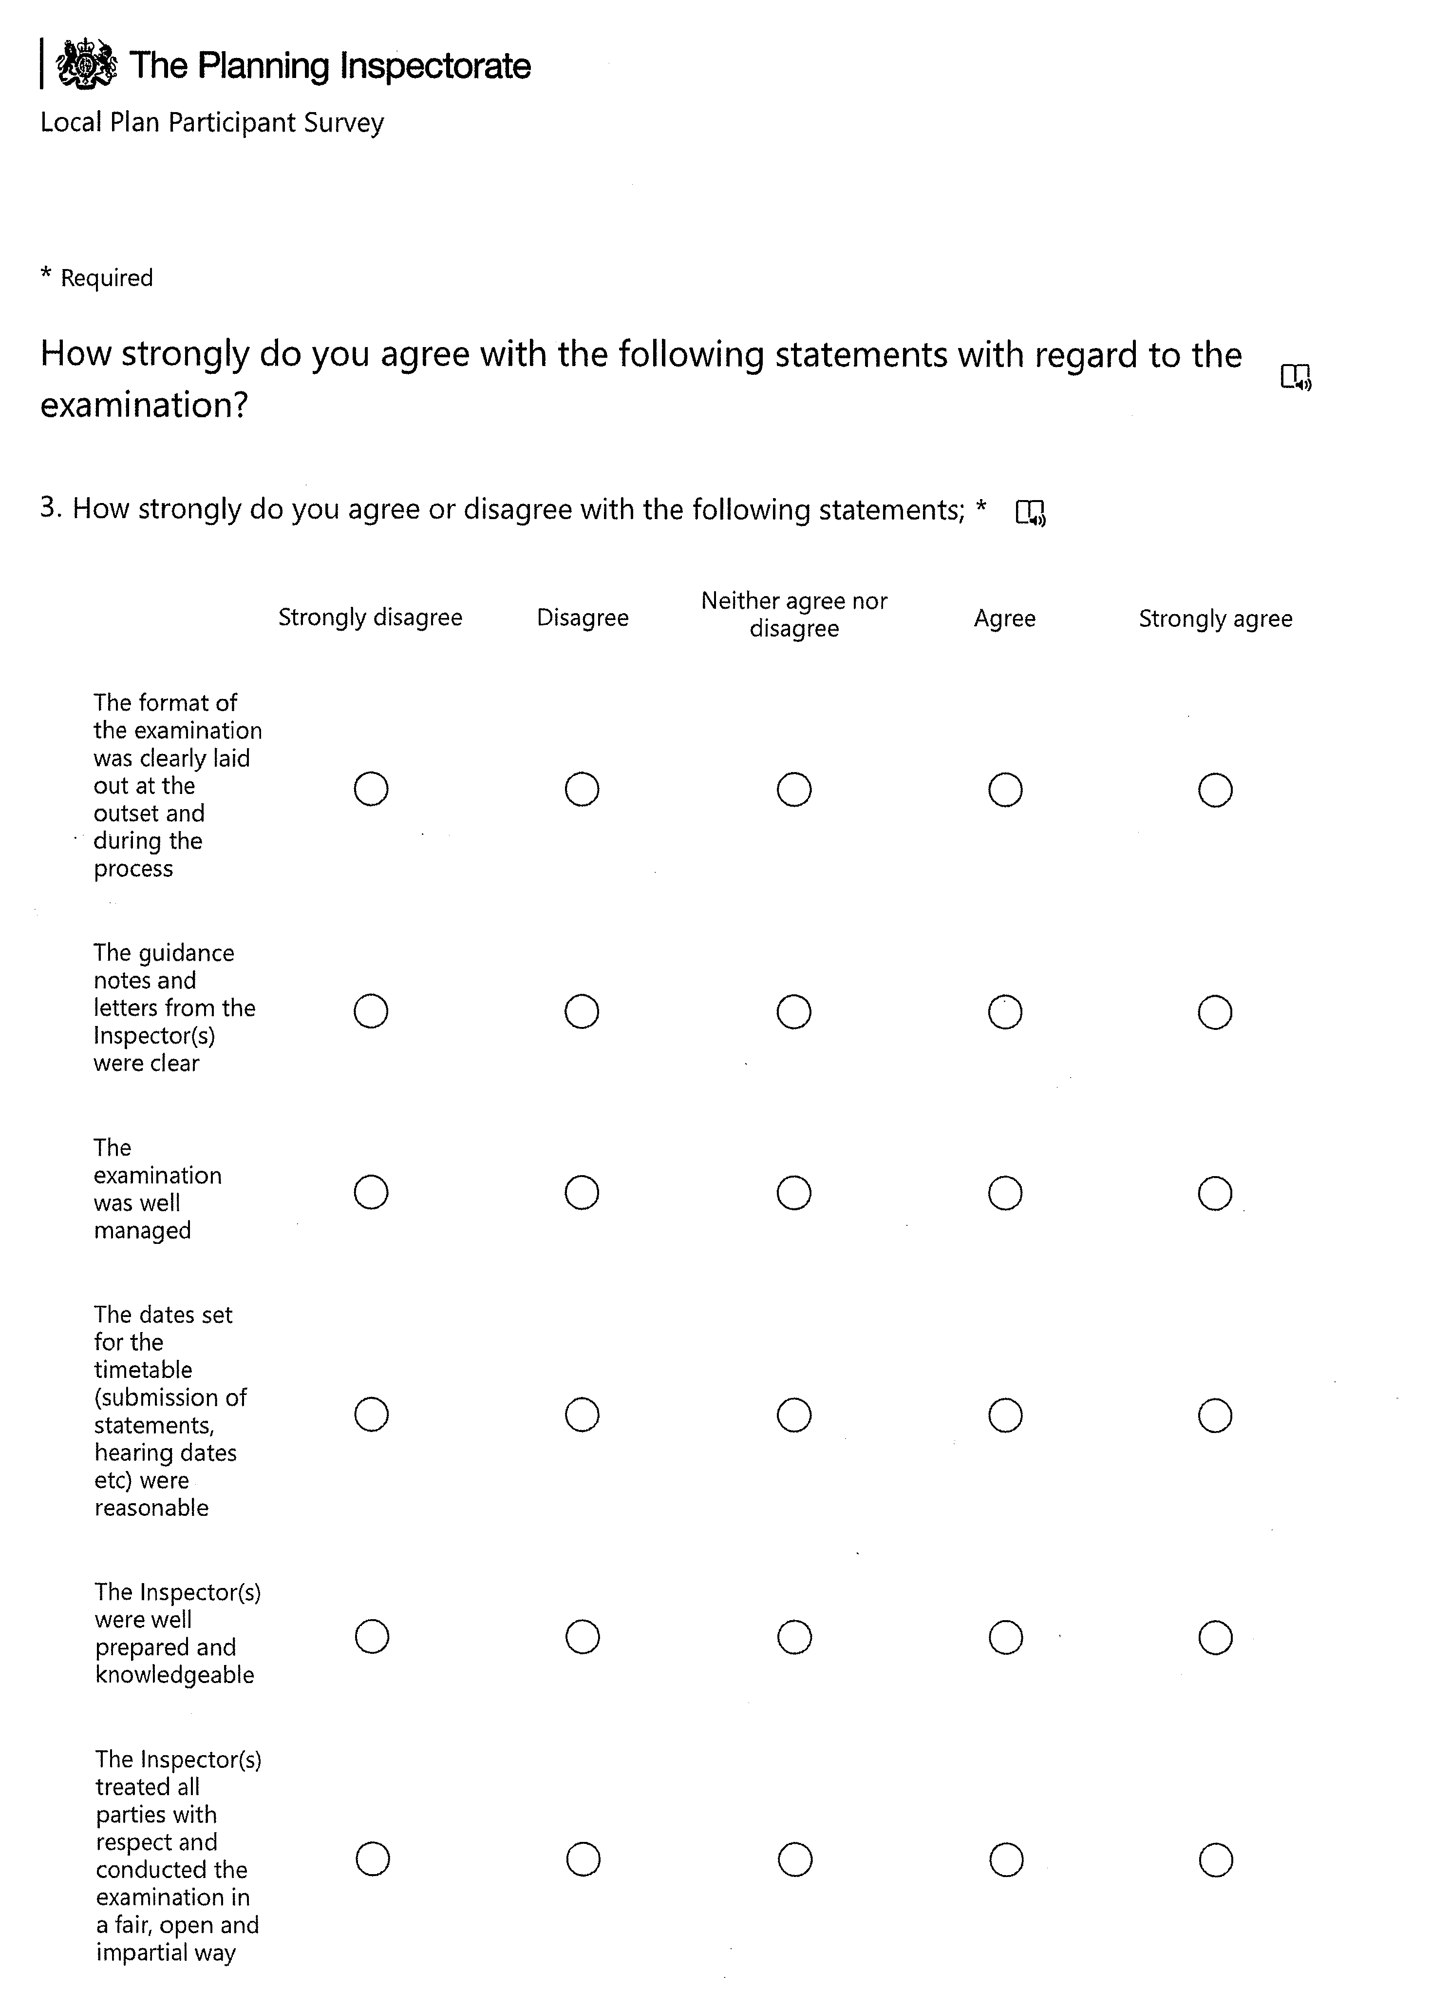
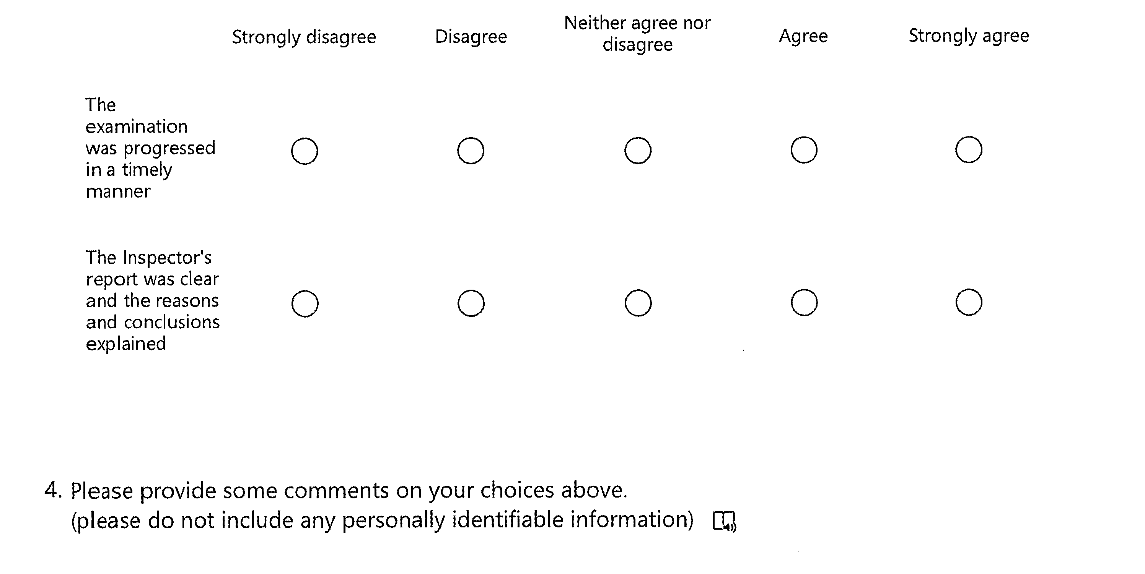

20. Siting of Caravans in the AONB - Information

Location
The caravan can be situated anywhere within the residential curtilage. It is common to identify a specific location within the planning application, but this is not essential in terms of law – it does however help keep the planning authority happy!

Use
The caravan MUST be used in conjunction with the main house. The specific term is ‘incidental to the enjoyment of’, so whatever use the caravan enjoys cannot be a primary use (i.e. main living area for the whole household).
Does the annexe (caravan) meet the legal definition of a mobile home in the Caravan Act? (Section 29 of the Caravan Sites Act 1968 states that the structure must be physically capable of being moved from one place to another by road and that the twin unit must be no more than 20 metres long, 6.80 metres wide and the living accommodation no more than 3.096 metres high)
Will the granny annexe remain ancillary to the main house?
In simple terms, planning permission is required for placing a static caravan on land UNLESS it is being used as ancillary accommodation for a house, such as for a dependent relative or holiday accommodation for visiting family members. It is best to check with your local planning authority to determine the specific laws and regulations in your area, as you may be subject to additional restrictions if you live in an Area of Outstanding Natural Beauty (AONB), or conservation area, for example.
If the use of a caravan is not considered to be a part of or incidental to the use of the house and has become a separate dwelling, providing all the normal facilities for day-to-day living, then it could be considered a material change of use or a separate residential unit. Thus the caravan would require permission.
Applying for planning permission has a high chance of refusal, and there are likely to be restrictions and/or conditions attached as to what is permitted if approval is granted, eg. the style must be ‘in keeping’ with the area or the primary dwelling.

Land use/ not development
Often misunderstood by planning authorities, the use of a caravan – even a large twin unit static caravan, is land use, and not development. In planning terms development generally refers to something that is built, or constructed (i.e. a building), where, because a caravan must be shown to be mobile, it cannot be classed as a building.
This can change, for example if the caravan unit becomes fixed down to the ground, or the use changes from an incidental use to a primary or secondary use. In this instance a planning application for development would be required.

Curtilage
This is absolutely critical, but can sometimes be surprisingly difficult to define. Typically the curtilage would be all of the land surrounding the house, on some occasions this may be quite extensive – i.e. include an orchard or small paddock, or even be a block of land not immediately adjacent to the land. In these instances it is essential to identify the extent of the residential curtilage prior to making an application.
If you want to live in a static caravan on a plot of private land, it will be necessary to apply for planning permission. There are all sorts of rules and variations to this and the first consideration will be what type of private land you’re proposing to put the static onto. For example: the garden rule is an anomaly regarding planning permission for static caravan on own land, the caravan must be within the garden area and not, say, within a paddock. Even if you consider the paddock part of the garden, in law it may not be classed as such. On agricultural land will need you to gain your main income from agriculture, even if you do get planning permission .Land types such as recreation, accommodation and woodland will carry different weights regarding getting permission in different areas and larger factors such as if the land is in “an area of outstanding natural beauty” (AONB) or “Site of special scientific interest” (SSI) where much greater planning restrictions will apply.
When it’s not within the garden footprint of the home, gaining planning permission for a static caravan can still be possible. Factors the local authority will consider are likely to be:The actual physical layout of the garden/land.The ownership of the property (past and present).The use or function of the land past and present.

Design and appearance
There are no criteria for design or appearance of the unit, as long as it meets the construction and mobility tests

Conservation areas / listed buildings / AONB’s
There are no limitations to the Caravan’s Act in relation to conservation areas, listed buildings, AONB’s, National Parks etc. as long as the critical criteria are met, permission should be granted.

Lawful Development Certificate
The siting of a caravan is essentially permitted in planning terms. To get confirmation of this permitted right, an application to the local council is made known as a Certificate of Lawfulness of Proposed Use or Development under section 192 of The Town and Country Planning Act (1990), this type of application is often shortened to Lawful Development Certificate.

21. Bell Lane – Illegal waste site

To consider further actions.

Daniela Baylis

Daniela Baylis

Clerk to the Council. Date 5 April 2024

