25 September 2020 | Contacts and Communities  London James Forbes House  27 Great Suffolk Street  London  SE1 0NS
Our ref: SCD/MB/BAM NUTTALL/CS/SBJ 41m 0440yds – SBJ 41m 1430yds

Dear neighbour,

Railway Improvement Works – Bearsted Cutting Stabilisation Works

I am writing to update you on the urgent works to stabilise the cutting in the Bearsted area from the 14 September 2020 until late 2021. The works will involve stabilising the rock cutting on both sides of the railway line to make sure that the railway remains safe and open for trains to be able to operate.

We will be holding a Zoom virtual community drop-in session on the 7 October 2020 from 17:00 to 19:00 where you will be able to drop in at any time during this time. Representatives from the project team and BAM Nuttall the contractor who will be delivering the work on behalf of Network Rail we will be presenting an overview of the stabilisation works and will be able to answer any questions that you may have.

To join using video from a computer, a tablet or a smartphone:
- Go to: Zoom.us in your Internet browser or the Zoom app.
- Click ‘Join a Meeting’
- Enter the meeting ID: 890 0498 6585
- Enter the passcode: 627911
To join the call using only audio from a telephone:
- Dial: 0131 460 1196
- Enter the meeting ID: 890 0498 6585
- Enter the passcode: 627911
The works will be completed in three phases and this letter is to inform you about Phase 1 of the works, which started on the 14 September 2020 from 07:30 – 17:30 Monday to Friday. We will write to you again to update you on these works as they progress.

Work will take place during a line closure of the railway as follows:
TIME | DATE |  | TIME | DATE
01:55 | 3 October 2020 | - | 04:55 | 5 October 2020

Further weekend and/or night-time track access may be required for the project. This requirement is under review and we will capture any additional plans in our next communications.
The work will involve clearing trees and vegetation along the length of the cutting between the junctions of Cornflower/Meadowdown/Grovewood Drive South and Ashford Road. Most of the vegetation clearance will be on the cress (top) and slope of the cutting. Where possible we will leave as many mature trees along the boundary fence that is safe to be able to leave and which does not impact the design for the permanent works.

To facilitate these works there will be a lane closure with temporary traffic lights on Grovewood Drive South commencing from the 14 September 2020. The lane closure will give us an area to set up our main site compound and provide safe access to the top of the railway cutting.

We will be using a combination of steel mesh and soil nails to hold the rock face in place. The mesh will be secured by drilling rock anchors into the cutting face at various points and then securing the mesh. This will prevent further failures of the cutting and make sure that the railway remains open and safe for passengers.

We will be using long-reach excavators and a rig that is anchored to the top of the cutting. We will be abseiling down the cutting face with the rig to carry out these works. Due to the nature of the work and the equipment we need to use you may experience some disturbance. However, every effort will be made to minimise as much noise a possible.

Below is a map showing the area of the cutting where we will be working.
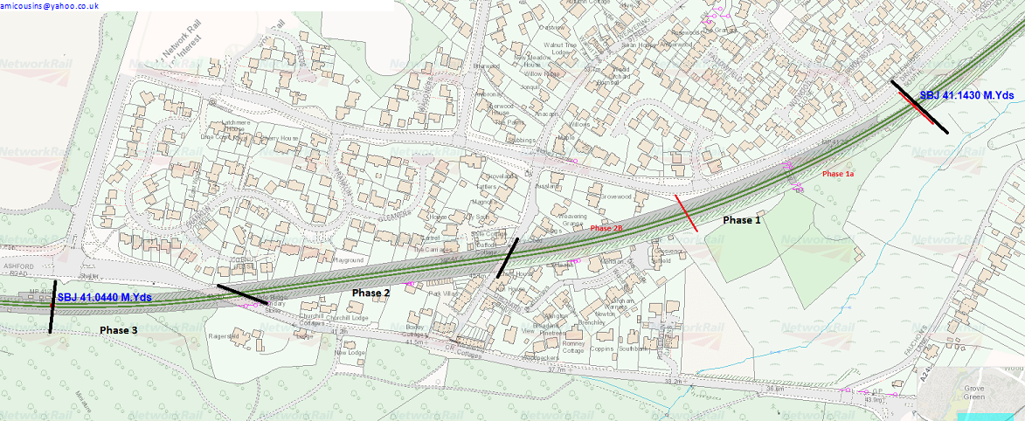

I hope this information is helpful and we apologise for any inconvenience these essential works may cause. However, if you have any additional questions or concerns, please visit
www.networkrail.co.uk or telephone our 24-Hour National Helpline on 03457 11 41 41 quoting Bearsted Cutting Stabilisation Works.

Yours faithfully
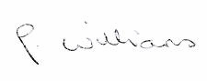
Paula Williams
Community Relations – Kent & Sussex Routes

